Apply the minimax algorithm to the game tree below, where it is the minimizer’s turn to play. Report the estimated values of the intermediate nodes and indicate the proper move of the minimizer.

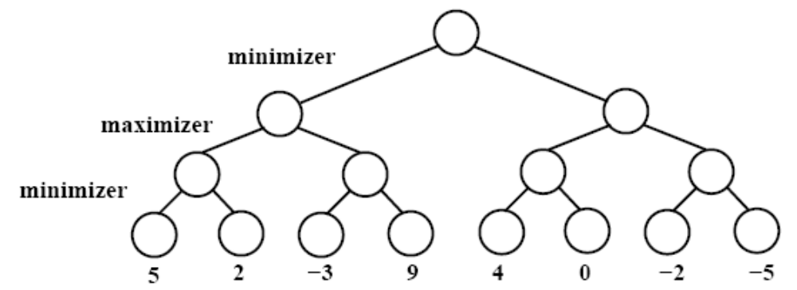
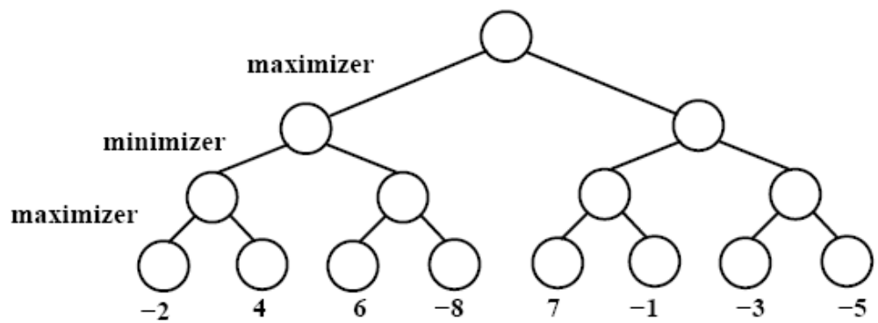
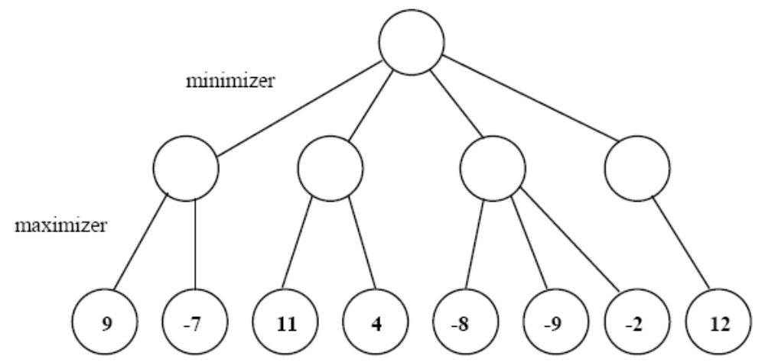
Indicate, by crossing out, one (1) unnecessary call to the static board evaluator. Explain why this call to the board evaluator is unnecessary.

[15] Consider the following game tree. Assume it is the maximizing player’s turn to move. The values at the leaves are the static evaluation function values of the states at each of those nodes.
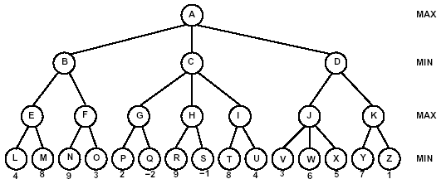
A
A
O
W
-
3
B
N
4
F
G
-
5
X
-
5
E
D
0
C
R
0
P
9
Q
-
6
S
3
T
5
U
-
7
V
-
9
K
M
H
3
I
8
J
L
2
max
min
max
max
min
O
O
O
(a) [4] Label each non-leaf node with its minimax value.
(b) [1] Which move would be selected by Max?
B
(c) [8] List the nodes that the alpha-beta algorithm would prune (i.e., not visit)? Assume children of a node are visited left-to-right.
O H R S I T U K Y Z
(d) [2] In general (i.e., not just for the tree shown above), if we traverse a game tree by visiting children in right-to-left order instead of left-to-right, will this result in a change to the following. Just answer Yes or No.
(i) The minimax value computed at the root?
No
(ii) The number of nodes pruned?
Yes

[12] Alpha-Beta Search
Consider the following game tree in which the static evaluation function values are shown below each leaf node. Assume that the root node corresponds to the maximizing player. Assume the search always visits children left-to-right.
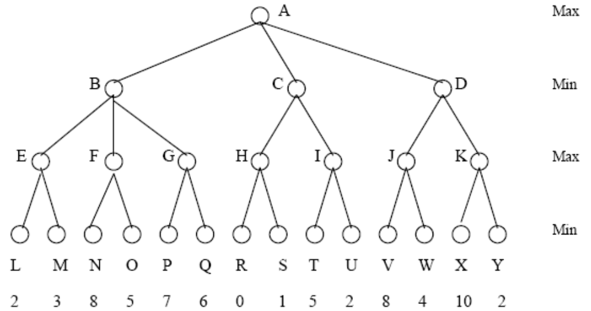

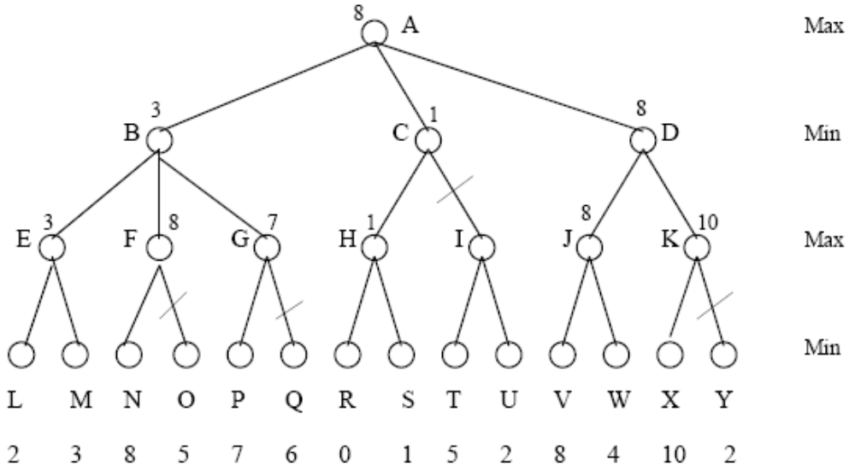

(a) [5] Compute the (final) backed-up values computed by the alpha-beta algorithm. Show your answer by writing values at the appropriate nodes in the above tree.
(b) [5] What nodes are not examined by alpha-beta?
O, Q, I, T, U, Y
(c) [2] What move should Max choose?
D

[17] Game Trees
The game of Nim2 is played as follows: Initially, there are two piles, each containing two sticks. Two players alternate turns, and at each turn the current player removes any positive number of sticks from any one pile. At least one stick must be removed during a turn. The player who’s turn it is when there are no more sticks to remove wins. Say we represent a state in this game as (#-sticks-in-pile1, #-sticks-in-pile2, Player), where Player is either A or B and indicates which player’s move is next. Player A goes first, so the initial state is (2,2,A).
(a) [10] Draw the complete game tree for Nim2. Show this as a tree, so states may be repeated.
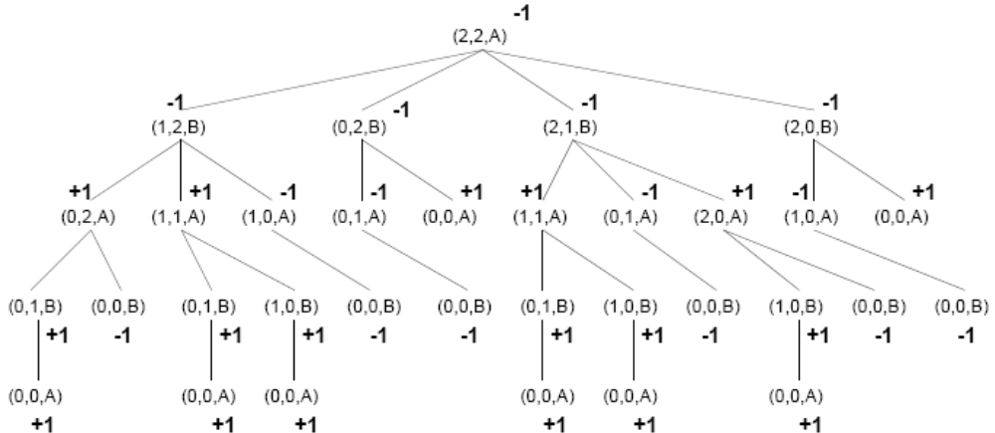

(b) [5] Assume you are Player A, and a winning state for A is assigned a utility value of +1, and a winning state for B is assigned a utility value of -1. Compute the minimax values for each of the states in the tree shown in your answer in (a). Write the values next to the nodes in your answer in (a).
(c) [2] Given that the complete game tree was used in (b) to compute the minimax values at all nodes based on true utility values at final game positions, explain briefly what the minimax value computed for the root node means.
The minimax value at the root is -1 and in this case means that
Player B is guaranteed to win.

[10] Alpha-Beta Pruning
Mark in each of the following two (2) game trees where alpha-beta pruning will occur. Assume the search always visits children left-to-right. If no cutoffs occur, write "none."
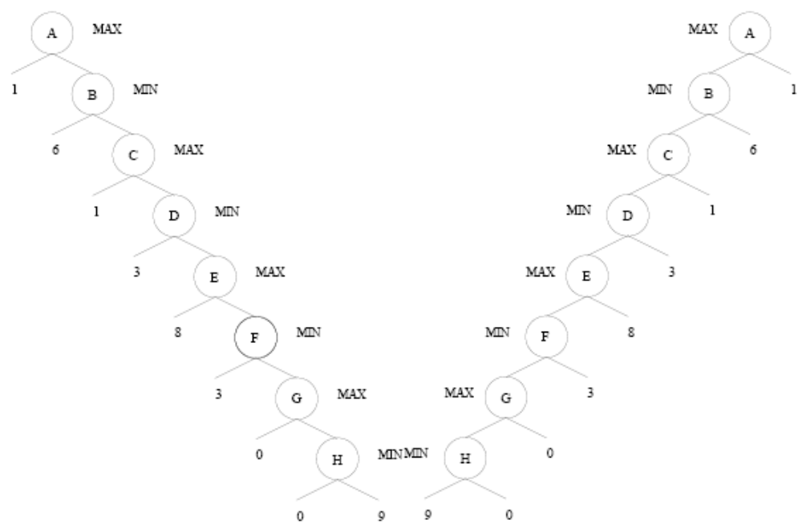
Left tree: cutoff at E (i.e., don’t visit F and below)
Right tree: none

A
A
O
W
-
3
B
N
4
F
G
-
5
X
-
5
E
D
0
C
R
0
P
9
Q
-
6
S
3
T
5
U
-
7
V
-
9
K
M
H
3
I
8
J
L
2
max
min
max
max
min

